Data Analysis Study Guide
Name: __________________________________________ Date: __________________

Shay’s test grades from first semester Language Arts were: 81, 85, 76 and 82.

- What is the mean of his test scores?

- What is the median of his test scores?

- What is the mode of his test scores?

Shay decided to retake the test he got 76 on. He worked really hard and got an 80, which means the 76 will come out of the gradebook and the 80 will go in.
- How will the new grade change the mean of his test scores?

- How will this new grade change the median of his test scores?

- What must be true to call a question statistical?

Which of the following are statistical questions? Write “Yes” on the line if the question is statistical and “No” if it is not.
- _____ What is the favorite flavor of lollipops?

- _____ How many students attend Elkins Pointe Middle School?

- _____ What is the average age of dogs on this street?

- _____ What is the lowest elevation in the ocean?

- _____How many students like pizza?

- _____ How many phone calls do sixth graders make each day?

Use the dot plot to answer questions below. Each dot represents 5 students.

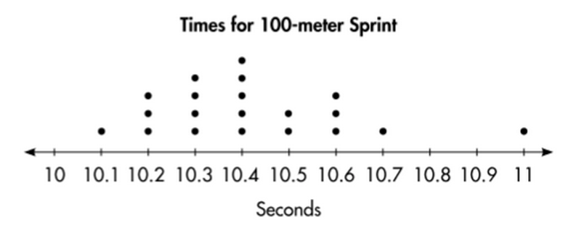

- How many students ran 100 meters in 10.5 seconds?

- What was the most common time?

- How many students raced?

- Label the shape of this plot. Use some of the following words: outlier, peak, cluster, and gap.

The following data set is the ages of patients at Sunshine Senior care:
{87, 89, 99, 89, 87, 74, 44, 98, 80, 99, 67}

- What is the mode of the data above?

- What is the median of the data?

- What is he mean of the data?
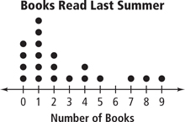
- The dot plot above shows the number of minutes students take to eat breakfast. Describe the shape of the data. Include some of the following words in your description: outlier, center, peak, skew, cluster, and gap.

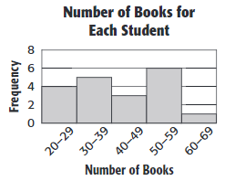
21. Which interval of books represents the most number of students?

22. Which interval has six students?

23. How many students read at least 40 books?

24. How many students read at most 39 books?

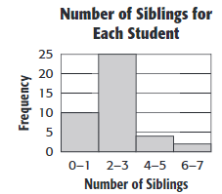
25. Which interval of books represents the least number of students?

26. How many students have 2-3 siblings?

27. How many students have greater than or equal to 4 siblings?

28. How many students have less than or equal to 3 siblings?
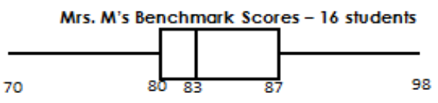
29. Find the following information for the box and whisker plot:
Minimum:
Q1:
Median:
Q3:
Maximum:
Interquartile Range:

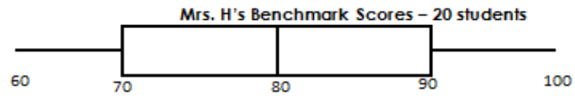
30. Find the following information for the box and whisker plot:

Minimum:
Q1:
Median:
Q3:
Maximum:
Interquartile Range:

Word | Meaning
Data
Statistical Question
Mean
Median
Mode
Range
Interquartile Range
Maximum
Minimum
1st Quartile
3rd Quartile
Peak
Cluster
Gap
Outlier

