Area of Trapezoids Notes

How To Write The Area Formula:

Find the area of each figure. Round to the nearest tenth if necessary.

1. 2.
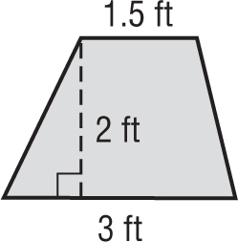
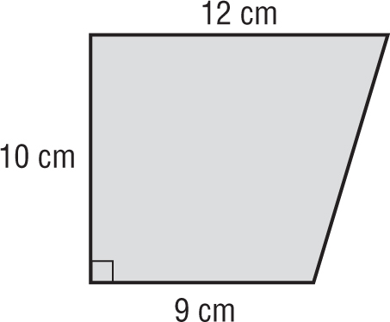

3. 4.
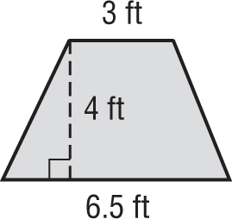
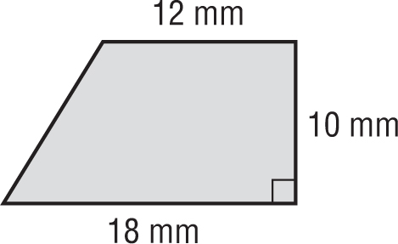

5. 6.
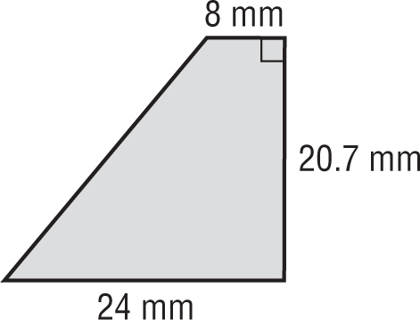
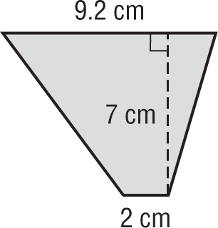

7. trapezoid: bases 5 ft and 3.5 ft, height 7 ft

8. DESKS What is the area of the top of the desk shown at right? 