How To Find The Area Of A Triangle

The area of a triangle is half the product of the base and the height. Why?

How we write the formula:

Hypotenuse: the longest side of the triangle (opposite the right angle). We DO NOT use this side when finding the area!!!

Find the area of each triangle.
1. 2. 3.
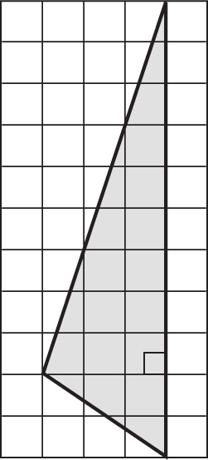
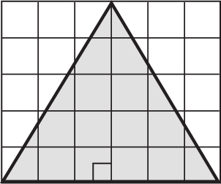
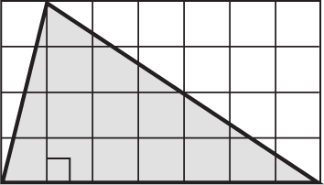

4. 5. 6.
