Homework Practice: Area of Trapezoids

Find the area of each figure. Round to the nearest tenth if necessary.

1. 2. 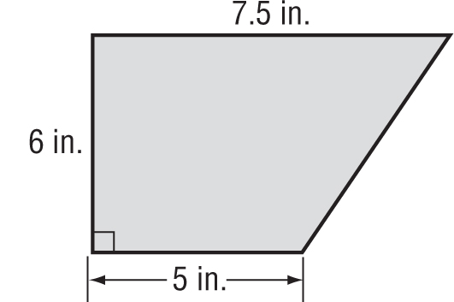
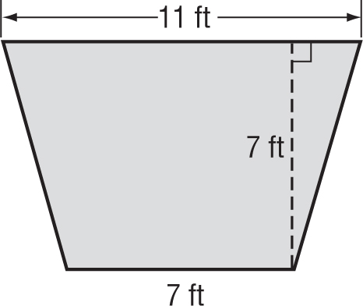

3. 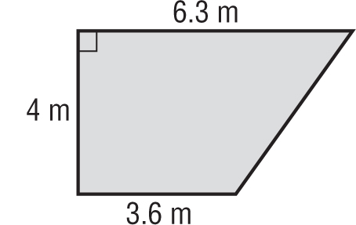 4. 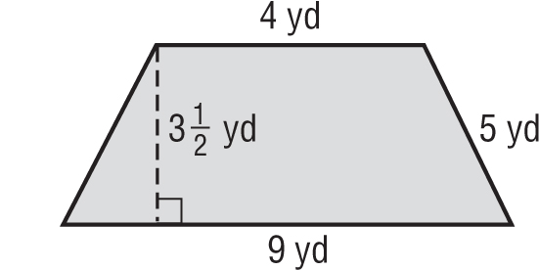

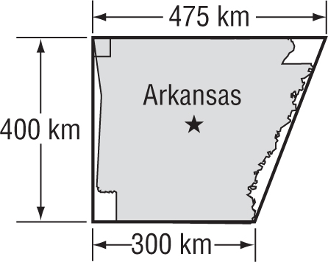
5. GEOGRAPHY The shape of Arkansas is roughly trapezoidal with bases of 475 kilometers and 300 kilometers and a height of 400 kilometers. What is the approximate area of Arkansas?

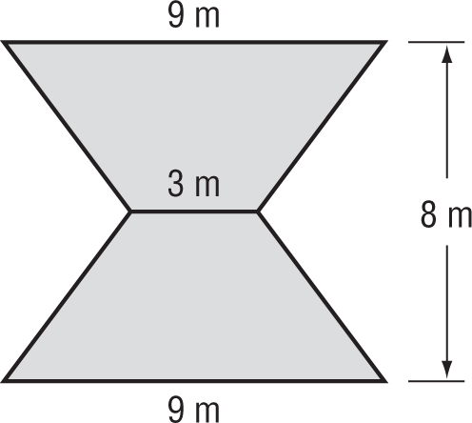
6. Find the area of the figure. It is formed by two congruent trapezoids.

