Homework Practice: Area of Triangles

Find the area of each triangle.

1. 2. 3.
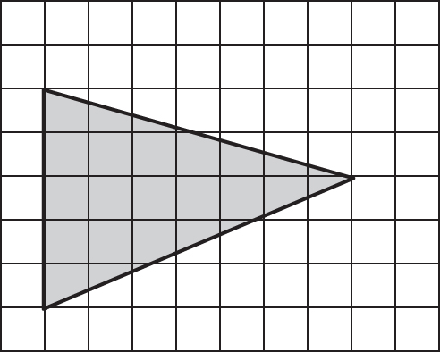
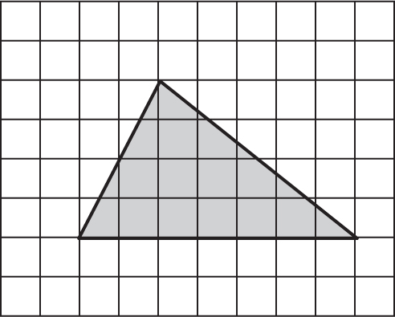

4. 5. 6.
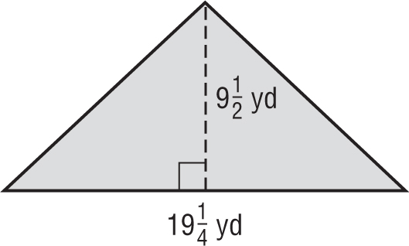
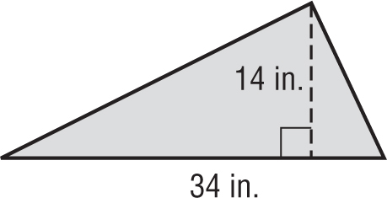
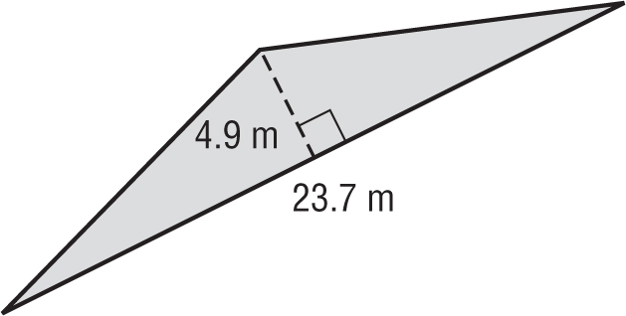

Find the missing dimension.
7. height: 15 ft 8. base: 17 cm
area: 285 ${ft}^{2}$ area: 18.7 ${cm}^{2}$

