Lesson: Box Plots (aka Box and Whisker Plots)
A box plot, or box-and-whisker plot, uses a number line to show the distribution of a set of data by using the median, quartiles, and extreme values. A box is drawn around the quartile values, and the whiskers extend from each quartile to the extreme data points that are not outliers. The median is marked with a vertical line.
Box plots separate data into four parts. Even though the parts may differ in length, each contains 25% of the data. The box shows the middle 50% of the data.
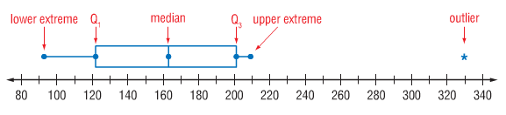

Example 1: Draw a box plot of the car speed data.
Median: Maximum:

Minimum: Q1:

Q3:

25 35 27 22 34 40 20 19 23 25 30

Step 1: Order the numbers from least to greatest. Then draw a number line that covers the range of the data.
Step 2: Find the median, the maximum, the minimum, the first quartile, and the third quartile. Mark these points above the number line.
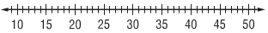
Step 3: Draw the box so that it includes the quartile values. Draw a vertical line through the box at the median value. Extend the whiskers from each quartile to the extreme data points. Include a title.
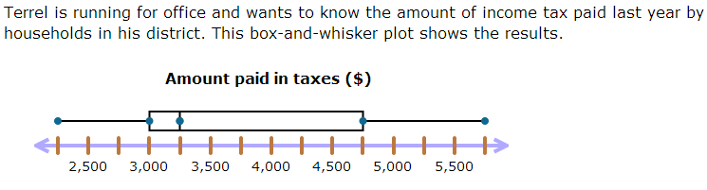

Find the measures of variability:
Median: Q1:

Q3: Range:

Interquartile Range: Outlier:

How to Make a Box Plot:
T - Title
O - Put data set in order, least to greatest
C - Create a number line
M - Median
L - Lower extreme (smallest #)
U - Upper extreme (largest #)
L - Lower quartile
U - Upper quartile
D - Draw box-whiskers
Example 3: Draw a box plot of the data set below.
15 16 17 17 18 19 20 21 22

Median:
Maximum:
Minimum:
Q1:
Q3:

