Rate: a ratio comparing two quantities with different units.
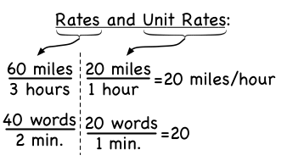
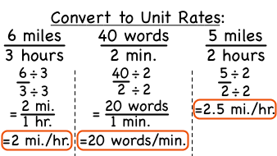
Unit Rate: a rate that is simplified so that it has a denominator of 1

Write each rate as a unit rate.

1. 14 hours in 2 weeks 2. 36 pieces of candy for 6 children

3. 8 teaspoons for 4 cups 4. 8 tomatoes for $2

5. $28 for 4 hours 6. 150 miles in 3 hours

7. $18 for 3 CDs 8. 48 logs on 6 trucks

9. Write the ratio $12 dollars for 3 tickets as a unit rate.

10. CHORES Wayne raked 30 bags of leaves in 3 hours. If he raked the same number of bags each hour, how many bags of leaves did he rake in one hour?

11. QUIZZES Mr. Ordonez gives his math students 34 quizzes during 17 weeks of school. If he gave the same number of quizzes each week, how many quizzes does Mr. Ordonez give his students every week?

12. TOURS It cost Mrs. Sapanaro $245 for her and 6 people to take a day-long guided tour of the Everglades. How much does the guided tour cost per person?

13. RUNNING Stephanie ran 1 lap in 6 minutes. At this rate, how far would she run in 30 minutes?

14. ALTITUDE In general, the air temperature decreases 12°F for every 4,000 feet increase in altitude. If a hiker climbs 3,000 feet, by how much can she expect the temperature to decrease?

15. PURCHASES One bottle of shampoo costs $6 for 8 ounces. A second bottle costs $4 for 5 ounces of shampoo. Which has the lower unit rate? How much lower?

