**Homework Practice: *Area of Composite Figures***

**Find the area of each figure. Round to the nearest tenth if necessary.**

**1. 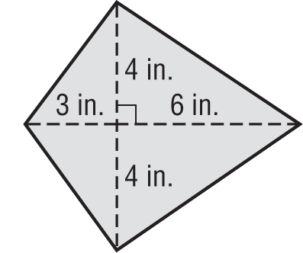 2.** 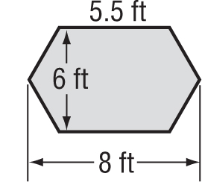

**3. 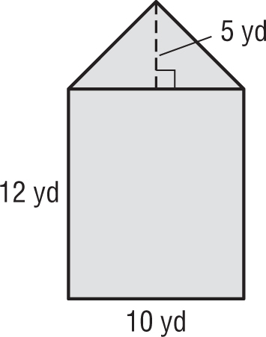 4.** 