Area of Composite Figures

ARCHITECTURE For Exercises 1–4 , use Ms. Rankin’s preliminary design of her vacation house at the beach. Round to the nearest tenth if necessary.

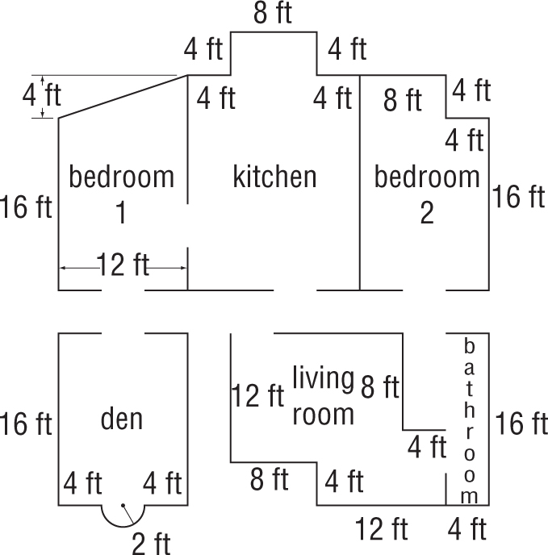

1. What type of figure is bedroom 1? Find the area of bedroom 1. | 2. What is the area of the bedroom 2? What figures did you use to find the area?
3. What is the area of the bathroom? What are the dimensions of the figures you used to find this area? | 4. What is the area of the kitchen? How many figures did you use to find this area?

