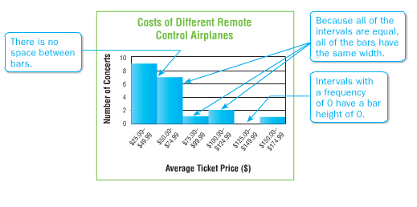
Histograms
Data from a frequency table can be displayed as a histogram. A histogram is a type of bar graph used to display numerical data that has been organized into equal intervals. These intervals allow you to see the frequency distribution of the data, or how many pieces of data are in each interval.
Scales and Intervals: It is important to choose a scale that includes all of the numbers in the data set. The interval should organize data to make it easy to compare.

Example 1: Refer to the histogram above. Describe the histogram. How many remote control airplanes cost at least $100? How many remote controls airplanes cost less than $75?

Daily Visitors to
Selected State Parks
Visitors | Tally | Frequency
100-149
150-199
Example 2: The table shows the number of daily visitors to selected state parks. Draw a histogram to represent the data.
Step 1: Make a frequency table to organize the data. For this example, use a scale from 100 through 399 with an interval of 50.
Step 2: Draw and label a horizontal and vertical axis. Include a title. Show the intervals from the frequency table on the horizontal axis. Label the vertical axis to show the frequencies.
Step 3: For each interval, draw a bar whose height is given by the frequencies.
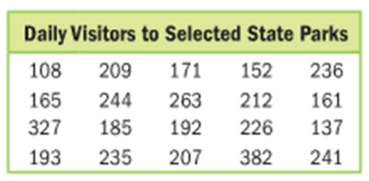

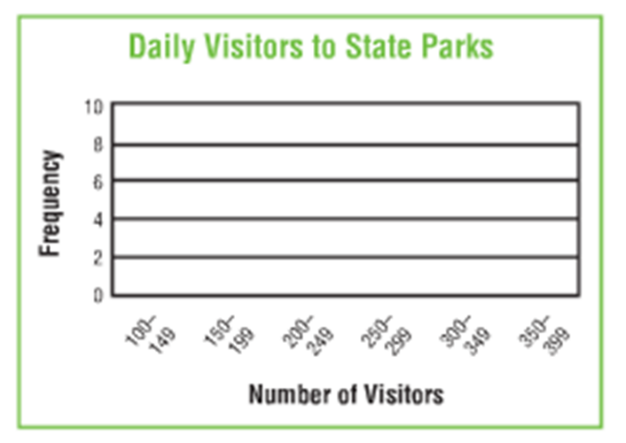

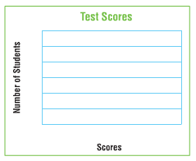
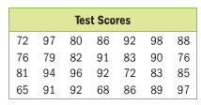
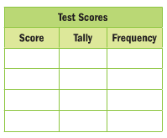
Example 3: The list shows a set of test scores. Choose intervals, make a frequency table, and construct a histogram to represent the data.

60-69
70-79
80-89
90-99

