Practice: Histograms
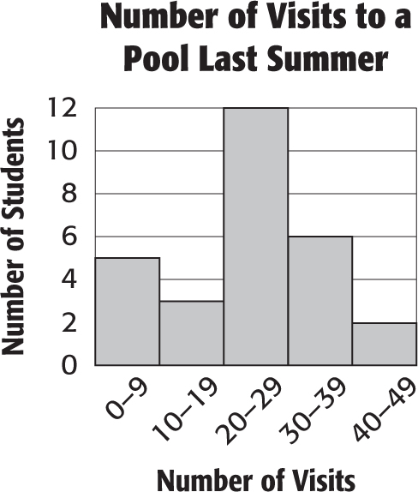
For Exercises 1–4, use the histogram shown at the right.

1. Which interval represents the most number of students?

2. Which interval has three students?

3. How many students went to a pool at least ten times last summer?

4. How many students went to a pool less than ten times last summer?

Draw a histogram to represent each set of data.
Weights of Pumpkins
Weight (lb) | Tally | Frequency
0–4 | |||| | 4
5–9 | |||| |||| | 10
10–14 | |||| |||| || | 12
15–19 | |||| ||| | 8
20–24 | |||| | 5
25–29 | | | 1

5. 6.
Lengths of Snakes
Length (in.) | Tally | Frequency
12–23 | |||| |||| | 10
24–35 | |||| |||| | 10
36–47 | |||| || | 7
48–59 | |||| | 5
60–71 | |||| | 4

7. number of points scored in each basketball game: 28, 16, 38, 44, 21, 38, 35, 48, 33, 29, 37, 39, 18, 38, 42, 37, 32
8. speeds of roller coasters (mph): 62, 64, 72, 75, 71, 68, 55, 58, 68, 72, 70, 60, 72

