Practice: Box Plots

Draw a box plot for each set of data.

1. ages of children taking dance classes: 10, 8, 9, 7, 10, 12, 14, 14, 10, 16

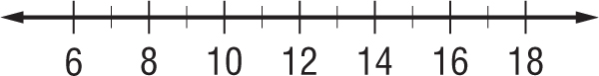

2. prices, in dollars, of bicycles: 150, 134, 136, 120, 145, 170, 125, 130, 145, 190, 140

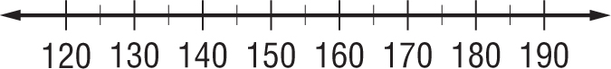

3. PRODUCTS Use the box plot that shows the average prices in cents per pound farmers received for eggs and wool.
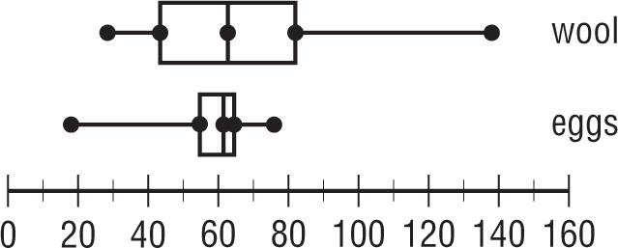

a. How do the median egg prices and the median wool prices compare?

b. How do the range in egg prices and the range in wool prices compare?

