Practice: Line Plots

The line plot below represents the total number of runs scored in each game by Tatiana’s softball team this year. Use the information on the line plot to answer the questions.
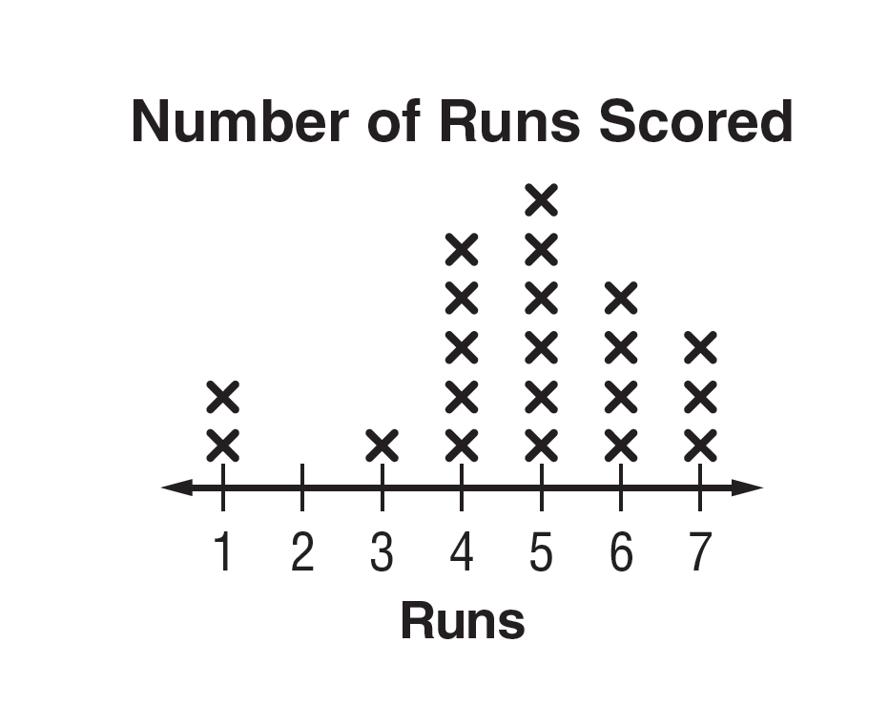

1. How many times did the team score 6 runs?

2. What is the median number of runs scored?

3. What is the mode of the data?

4. Find the range and any outliers of the data.

For Exercises 5 and 6, make a line plot for each set of data. Find the median, mode, range, and any outliers of the data shown in the line plot. Then describe the data using them.

5. golf scores: 39, 46, 48, 48, 39, 51, 44, 42, 48, 45

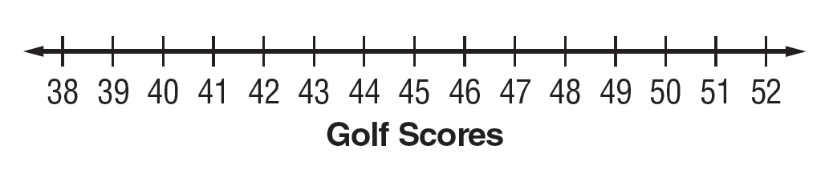

6. number of cans of food donated:
28, 20, 20, 22, 21, 22, 20, 21, 21, 21, 21

