One way to give a picture of data is to make a line plot. A line plot is a visual display of a distribution of data values where each data value is shown as a dot or another mark, usually an X, above a number line. A line plot is also known as a dot plot.
Example 1: Jasmine asked her class how many pets they have. The results are shown in the table. Make a line plot of the data. Then describe the data presented in the graph.
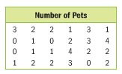
Step 1: Draw and label a number line
Step 2: Place as many Xs above each
number as there are responses
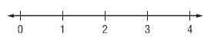
for that number. Include a title.
Step 3: Describe the data.

Got it? Do this problem to find out.
A. Javier asked the members of his 4-H club how many projects they were taking. The results are shown in the table. Make a line plot of the data. Then describe the data in the graph.
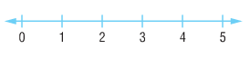
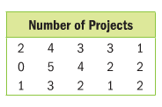

You can describe a set of data using measures of center. The range of the data and
any outliers are also useful in describing data.
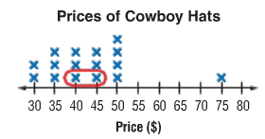
Example 2: The line plot shows the prices of cowboy hats.
- Find the median and mode of the data.
Then describe the data using them.

- Find the range and any outliers of the data.
Then describe the data using them.

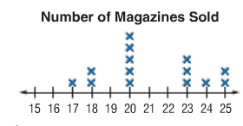
Got it? Do this problem to find out.
B. The line plot shows the number of magazines each member of the student
council sold. Find the median, mode, range, and any outliers of the data.
Then describe the data using them.
Median: Mode:
Range: Outliers:

Example 3: The line plot shows the amount James deposited in his savings account each month. Describe the data. Include measures of center.
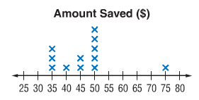
Mean: Mode:

Median: Range:

Q1: Q3:

Interquartile Range: Outliers:

