Milestones Review

Write each ratio as a fraction in simplest form.

1.
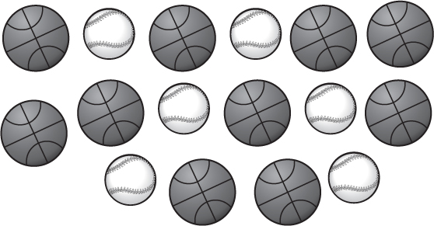

baseballs to basketballs

2. 12 kittens to 15 puppies

3. CLOTHING At the ticket booth at a Florida Marlins game, 15 people wore turquoise and 24 people wore gray. What is the ratio of people
who wore turquoise to the people who wore gray in simplest form?
Favorite Music
Pop | 7
Country | 5
Dance | 4

4. MUSIC Mangi surveyed students about their favorite types of music.
Find the ratio of students who chose dance to the total number of students surveyed.

5. Write 90 words in 2 minutes as a unit rate.

6. GRASS SEED Mr. Ernesto spent $72 for 3 bags of grass seed. How much did he spend on each bag?

Use the ratio table to solve the problem.

7. MIXTURE A mixture requires 4 cups of water for every 7 cups of flour used. How many cups of water should be used with 28 cups of flour?
Cups of Flour | 7 | 28
Cups of Water | 4 | ∎

1. _____

2._______________

3.

4.
_____________________

5.

6.

7.

____
_____ ______________

