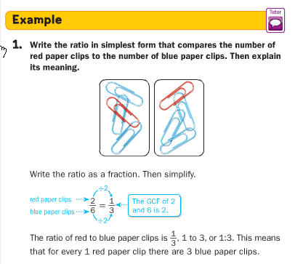
Unit 2 Lesson 1: Ratios

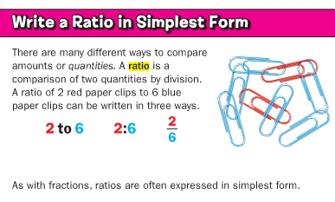

1. Find the ratio of shaded sections to striped sections. Then explain its meaning.  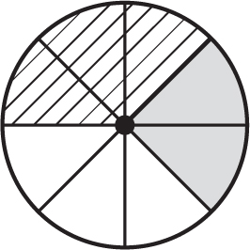 | 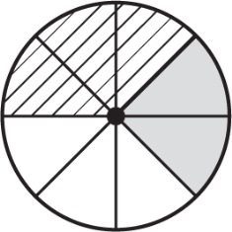  2. Find the ratio of shaded sections to the total number of sections. Write the ratio as a fraction in simplest form. Then explain its meaning.
3. What is the ratio of empty sections to striped or shaded sections? Explain its meaning. | 4. FOOTBALL In a recent NFL season, the Miami Dolphins won 4 games and the Oakland Raiders won 5 games. What is the ratio of wins for the Dolphins to wins for the Raiders?
5. GARDENING Rod has 10 rosebushes, 2 of which produce yellow roses. Write the ratio 2 yellow rosebushes out of 10 rosebushes in simplest form. | 6. AGES Oscar is 16 years old and his sister Julia is 12 years old. What will be the ratio of Oscar’s age to Julia’s age in 2 years? Write as a fraction in simplest form.

