1) Which expression equals 24?
A) | (2 + 4)(3)

B) | (4 x 2)(3)

C) | (4 + 3) - 2

D) | (4 - 2) + 3
2)
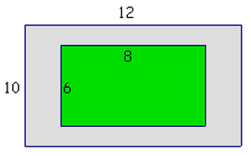
The gray area is the sidewalk. The area of the sidewalk is ___________ square units.
A) | 48

B) | 56

C) | 72

D) | 84

3) Fill in the blank with >,<, or =: 5.05 ___ 5.5
A) | >

B) | <

C) | =

D) | ≥
4) Winnie the Pooh goes to the honey store to buy a case of honey for the winter. The case of 24 jars of honey cost $27.60. What is the cost of each jar?
A) | $0.87

B) | $1.00

C) | $1.15

D) | $62.40
5) What is the value of 2w + 5, if w = 6?
A) | 17

B) | 24

C) | 30

D) | 36
6) If c = 30 and d = 8, then 2c + 4d =
A) | 512

B) | 278

C) | 136

D) | 92
7) Find the area of a parallelogram that has a base of 30 feet and a height of 20 feet.
A) | 25 ft²

B) | 50 ft²

C) | 600 ft²

D) | 2500 ft²
8) Which equation demonstrates the distributive property?
A) | 60 + 18 = 78

B) | 60 x 18 = 18 x 60

C) | 60 + 18 = 6(10 + 3)

D) | (10 + 3)6 = 6(10 + 3)
9)
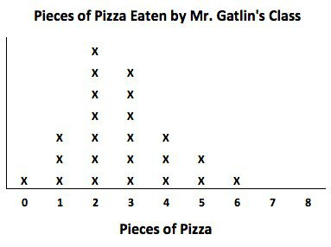
Mr. Gatlin had each of his students record how many pieces of pizza they ate during the class party.
What is the total number of students who actually ate pizza during the party?
A) | 20

B) | 21

C) | 22

D) | 23
10) The length of a rectangle is twice its width. If the width is 10, what is the area?
A) | 40

B) | 60

C) | 100

D) | 200
11)
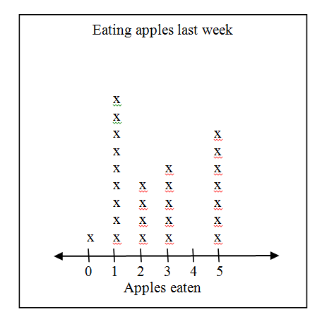
A chef kept track of the number of apples people ate last week in his cafeteria. The results are shown here.
How many people ate fewer than 2 apples last week?
A) | 3

B) | 7

C) | 10

D) | 11
12) Find: 5.57 + 0.1
A) | 5.561

B) | 5.57

C) | 5.67

D) | 6.57
13) Find the LCM of 8 and 12.
A) | 12

B) | 18

C) | 24

D) | 36
14)
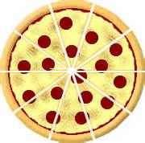
Sally bought the pizza shown above for lunch, which was cut into 10 equal slices. What percentage of the pizza did Sally eat if she had four slices?
A) | 20%

B) | 30%

C) | 40%

D) | 50%
15)

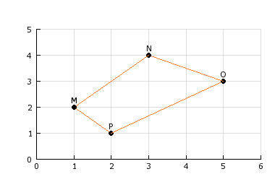
Which point is located at (3, 4)?
A) | M

B) | N

C) | O

D) | P
16)
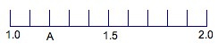
What number does point A represent?
A) | 0.1

B) | 0.2

C) | 1.02

D) | 1.2
17)
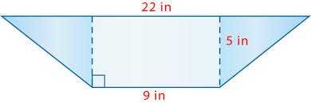
Find the area of the blue triangle on the left side of the trapezoid.
A) | 16.25 in²

B) | 32.5 in²

C) | 45 in²

D) | 65 in²
18) Suppose x = 2y - 7. What is x, if y = 5?
A) | 0

B) | 1

C) | 3

D) | 6
19) Which symbol makes the sentence true?
1.3$?4/3$

A) | <

B) | >

C) | =

D) | ≤
20) Find the area of a parallelogram that has a base of 24 feet and a height of 12 feet.
A) | 18 ft²

B) | 36 ft²

C) | 144 ft²

D) | 288 ft²
21)
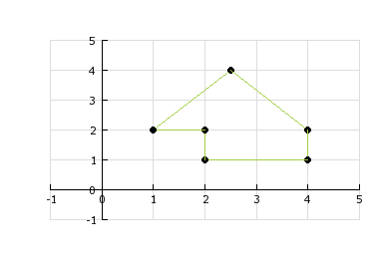
What is the approximate area of the geometric figure?
A) | 2 square units

B) | 3 square units

C) | 5 square units

D) | 8 square units
22)
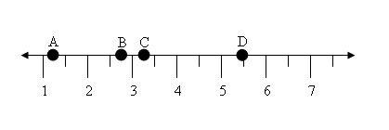
Which answer shows the number that point C represents on the graph?

- $3\frac{1}{2}$
- $3\frac{1}{4}$
- $3\frac{2}{4}$
- $3\frac{3}{2}$

23) Find the greatest common factor of 36 and 72.
A) | 1

B) | 2

C) | 3

D) | 36
24)
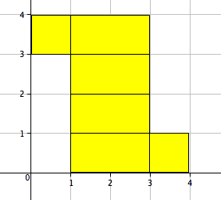
The net of a prism is shown on the coordinate plane. What is the surface area of the prism?
A) | 2 in²

B) | 9 in²

C) | 10 in²

D) | 16 in²
25) Solve.
x - 6 = 3
A) | x = -3

B) | x = 2

C) | x = 3

D) | x = 9

26)
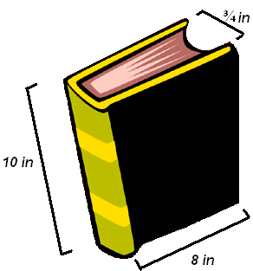
A 300-page book is 10 inches long, 8 inches wide, and ¾ inches tall. What is the volume of 100 pages of the book?

A) | 20 in.³.

B) | 60 in.³

C) | 188 in.³.

D) | 6,000 in.³.
27) Divide. $2\frac{1}{3} ÷\frac{2}{5}$

A) | 9  15

B) | 4  5

C) | 14  15

D) | 5  5  6

28) If A = James's present age, write an expression for his age seven years from now.
A) | 7A

B) | 7 - A

C) | A – 7

D) | 7 + A

29) A group of students are meeting in the cafeteria. 70 students have already arrived. This is 35% of the group. How many students are in the group?
A) | 200

B) | 255

C) | 500

D) | 2450
30) Jamaal is traveling 20 miles an hour slower than Micah. Micah is traveling n miles an hour. Write an expression to describe how fast Jamaal is traveling.
A) | 20n

B) | n + 20

C) | 20 - n

D) | n - 20
31) Trina's teacher asked her to explain the division problem 48 ÷ 12. Which choice gives the correct explanation?
A) | Break 48 into 4 groups of 12.

B) | Break 48 into 12 groups of 4.

C) | Break 12 into 4 groups of 48.

D) | Break 12 into 48 groups of 4.
32) What two numbers are 7 units from 0 on a number line?
A) | 7 and 8

B) | 7 and -7

C) | 9 and 2

D) | 10 and -10

33) What is $\frac{5}{7} ×\frac{3}{5}$
A) | 2  3

B) | 3  7

C) | 5  4

D) | $$\frac{8}{12}$$
34) Which of these statements is true?
A) | 349 > 456

B) | 456 < 792

C) | 792 < 456

D) | 792 > 863
35)

Cookies and price
b | c
4 | 12
6 | 18
9 | 27
The table shows the cost, c, of buying each number of boxes, b, of cookies. Write an equation that models this situation.
A) | b = 3c

B) | c = 3b

C) | b = 8c

D) | c = 8b

