Surface Area of Rectangular Prism Notes:
Surface area is the sum of the areas of all the faces (sides) of a 3-dimensional figure

1. 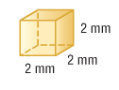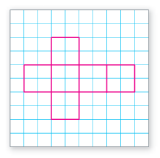

2. 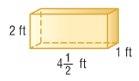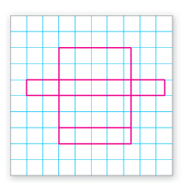

Surface Area of Triangular Prism Notes:
Surface area is the sum of the areas of all the faces (sides) of a 3-dimensional figure

1. 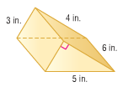 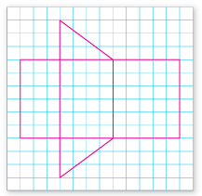

2. 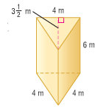 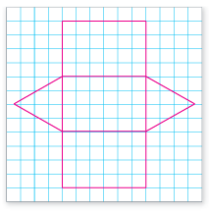

Surface Area of Pyramid Notes:
Surface area is the sum of the areas of all the faces (sides) of a 3-dimensional figure

1. 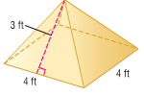 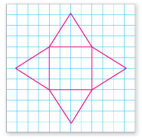

2. 