Unit 2 Study Guide: Ratios and Proportions
Name:____________________________________________________________________________________ Period: __________________ Due Date: ____________________________

What are the 3 ways to write a ratio? ____________________________________________________________________________________________
Ratios Standard- RP.1
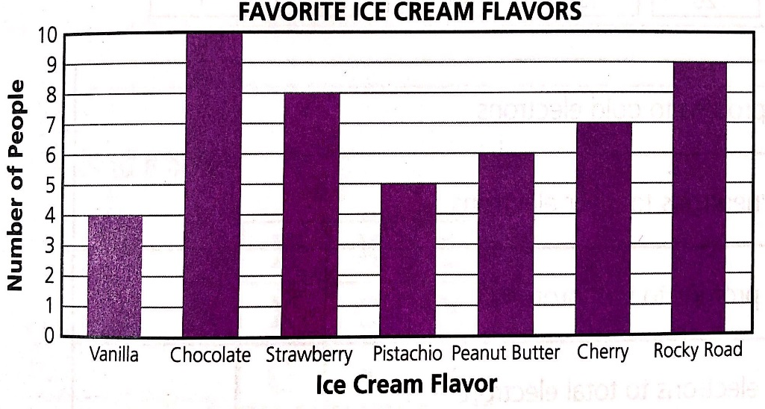 |  |  | - Write the ratio of chocolate to rocky road all three ways. Simplify if possible. |  | - Write the ratio of strawberry to total ice cream flavors all three ways. Simplify if possible.
- Write the ratio of vanilla to strawberry all three ways. Simplify if possible. | - Write the ratio of chocolate to vanilla & strawberry in all three ways. Simplify if possible. |  | - Write the ratio of the number of people whose favorite flavor is chocolate and rocky road to all people. Simplify if possible. |  | - Write the ratio of peanut butter to strawberry and chocolate. Simplify if possible.
Unit Rate Standard-RP.2, 3b
- Food Mart sells 12 water bottles for $2.69. What is the unit price per water bottle at Food Mart? | - Roger’s Market sells 6 water bottles for $1.49. What is the unit price per water bottle at Roger’s Market? |  | - Save-A-Lot sells 36 water bottles for $5.99. What is the unit price at Save-A-Lot? |  | - Which store has the best unit price for water bottles? Explain in complete sentences how you know.
- Denise does 225 jumping jacks in 3 minutes. At this rate, how many jumping jacks can she do in 5 minutes? | - Target charges $2.49 for 3 candy bars. How much does Target charge for 7 candy bars? |  | - A car travels 450 miles in 6 hours. How far did the car travel in 9 hours? |  | - Kroger charges $18.32 for 8 lbs of chicken. How much does Kroger charge for 3 lbs of chicken?
Ratio Tables Standard-RP.3a
- Luis bakes pancakes with a ratio of flour to liquid of 3 to 2. Use this information to complete the table below  Flour (cups) Liquid (cups)  6  15  24 |  | - John is making floral arrangements for the nursing home. John has a ratio of 7 roses to 9 sunflowers. Use this information to complete the table below.  Roses Sunflowers  9  36  49  70 |  | - Ms. Rankin saved $760 in 8 months to renew her annual pass to Disney World. Complete the table to show Ms. Rankin’s savings.  Months Savings  1  $285  5  $665
Graphing Ratio Table Standard- RP.3a
- Plot your ratio table for question 15 in the space provided. Be sure to label and title your graph. |  | - Plot your ratio table for question 16 in the space provided. Be sure to label and title your graph. |  | - Plot your ratio table for question 17 in the space provided. Be sure to label and title your graph.
Equivalent Ratios Standard- RP.3a, 3d
- George’s dad is booking a hotel for their upcoming family vacation. He wants to spend no more than $85 per day. Circle all of the hotels that fit into their budget? | Hotel: Amount Charged:  Hilton $180 for 2 days  Hampton Inn $336 for 4 days  Best Western $255 for 3 days  Marriott $465 for 5 days

