Unit 4 Study Guide: Equations and Inequalities
Name: ________________________________________ Date: ___________________________

Part 1: One Step Equations
Identify the solution of each equation from the list given. Circle the solution.

- s + 12 = 17; 5, 6, 7

- 44 = t − 10; 52, 53, 54

- 4r = 40; 8, 9, 10

- 28 ÷ w = 7; 3, 4, 5

Solve each equation. Check your solution.

- 4 + k = 11 k = ______

- 8w = 80 w = ______

- a + 6 = 11 a = ______

- 17 = 9 + e e = ______

- 24 = j – 34 j = ______

- k – 12 = 4 k = ______

- 9b = 36 b = ______

- 80 = 10d d = ______

- m ÷ 9 = 5 m = ______

- g ÷ 4 = 12 g = ______

Write an equation for each situation and solve it.

- Fun Time Roller Coasters charges $6 per
ride. Joe spends $54 on rides.

- Bonnie has 27 more cans than Jackie.
If she has 56 cans, write and solve an
equation to find how many cans Jackie has.

- Cornelius is saving money to buy a jacket
that costs $47. He has already saved $25.
Write and solve an equation to find how
much more money Cornelius needs to save.

- Keshav has $250 in his account. This is $75
more than his brother Nalin has in his account. Write and solve an addition equation to find the amount of money in Nalin’s account.

Part 2: Inequalities
Write an inequality for each sentence.
- More than 40,000 fans attended the opening football game at the University of Florida.

- Her earnings were no more than $86.

- A savings account balance is now less than $550.

- The number of club members is at least 25.

- The spring calf class at the cattle show is for
calves that weigh 825 pounds or less.

- The minimum deposit for a new checking account is $75.

Solve each inequality. Plot your solution on the number line under the inequality.

- 14n > 266

- n + 17 < 35
- 6x ≥ 138

- 2 ≤ x + 2

- b – 26 < 2

- 18 ≤ r + 11
Write the inequality shown by each graph:

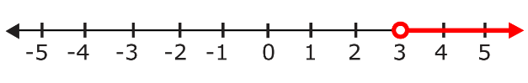

- Inequality: ___________________

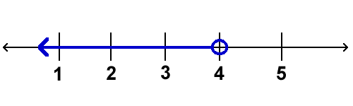
- Inequality: ___________________

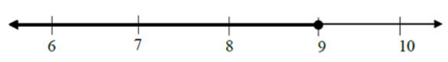

- Inequality: ___________________

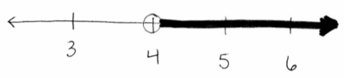
- Inequality: ___________________

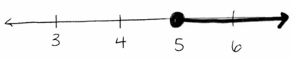
- Inequality: ___________________
Part 3: Functions

Write an equation for each function table and
find the value for the missing output.

- Equation: _______________________
Input (x) | Output (y)
5 | 0
6 | 1
7 | 2
8 | 3
9

- Equation: _______________________

Input (x) | Output (y)
2 | 14
 | 16
 | 18
8 | 20
10

Input (x) | Output (y)
4 | 0
5 | 1
6 | 2
7 | 3
9
- Equation: _______________________

- Equation: _______________________

Input (x) | Output (y)
1 | 11
2 | 22
3 | 33
4 | 44
6

Practice Free Response

Mark has been earning money by mowing his neighbors’ lawns. His goal for the summer is to have $1,200 in his savings account. If he charges $20 per lawn each time he mows, how long will it take him to reach his goal?

Step 1: Fill in the function table below:

Lawns Mowed
Amount in Savings

Step 2: Write an equation to show the relationship between the number of lawns he mows and how much is in his savings account.

Step 3: How many weeks will it take Mark to reach his goal?

