Unit 5 Study Guide: Area and Volume
Name: Period:

MCC6.G.1: Find the area polygons; apply these techniques in the context of solving real-world problems.  -Triangle Area:  ½bh  -Trapezoid Area:  ½h(b₁ + b₂)  -Parallelogram Area:  bh  -The height of a polygon ALWAYS goes from the highest point to the base.  -If a polygon has a fractional dimension, we must convert to improper fractions before we can multiply to calculate area | 1.  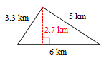  Polygon Name:_________________________  Area Formula:__________________________  Area:__________________________________  2.  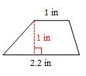  Polygon Name:_________________________  Area Formula:__________________________  Area:__________________________________  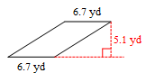  3.  Polygon Name:_________________________  Area Formula:__________________________  Area:__________________________________  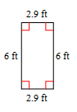  4.  Polygon Name:_________________________  Area Formula:__________________________  Area:__________________________________  5. Find the area of this figure:  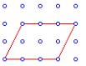  6. Find the area of this figure by decomposing into polygons:  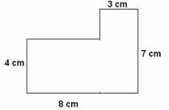  7. Ms. Marmiol is getting new hardwood floors in her living room. How many square feet of wood will she need to order if her living room is has this floor plan:  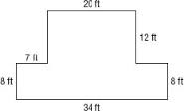
MCC6.G.3: Apply the formulas V = l w h and V = Bh to find volumes of right rectangular prisms. Apply this to solve real-world problems.  Volume of a rectangular prism= Bh, where B= area of the base  Volume = lwh | Find the volume of each:  8.  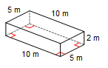  9.  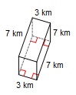  10.  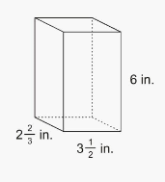  11. How much yogurt can I fit into my to-go box if it is this big?  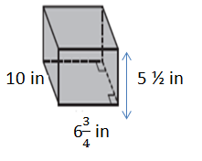  12. What is the volume of this solid if each cubic unit is ½ inch?  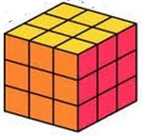
MCC6.G.4: Represent three-dimensional figures using nets made up of rectangles and triangles, and use the nets to find the surface area of these figures. | Find the surface area of each figure#13-15:  13.  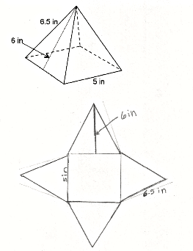  14.  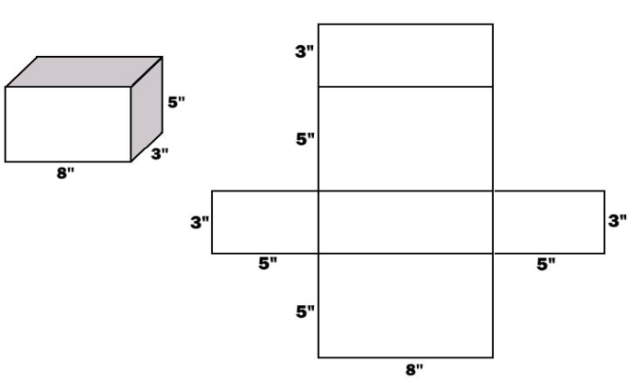  15.  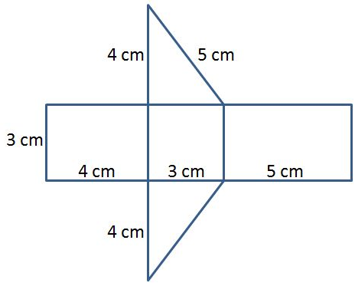

16. What is the difference between surface area and volume?

17. Explain, in detail, how to calculate how much carpet will be needed to cover this floor:
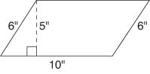
__________________________________________
___________________________________________
__________________________________________________

_____________________________________________________________________________

_____________________________________________________________________________
Mr. Thomas is wrapping a present to give Ms. Krishna. The box is pictured below along with its net:
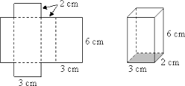
18. How much wrapping paper will Mr. Thomas need to cover the box?

19. How many cubic centimeters of present will the box hold?

